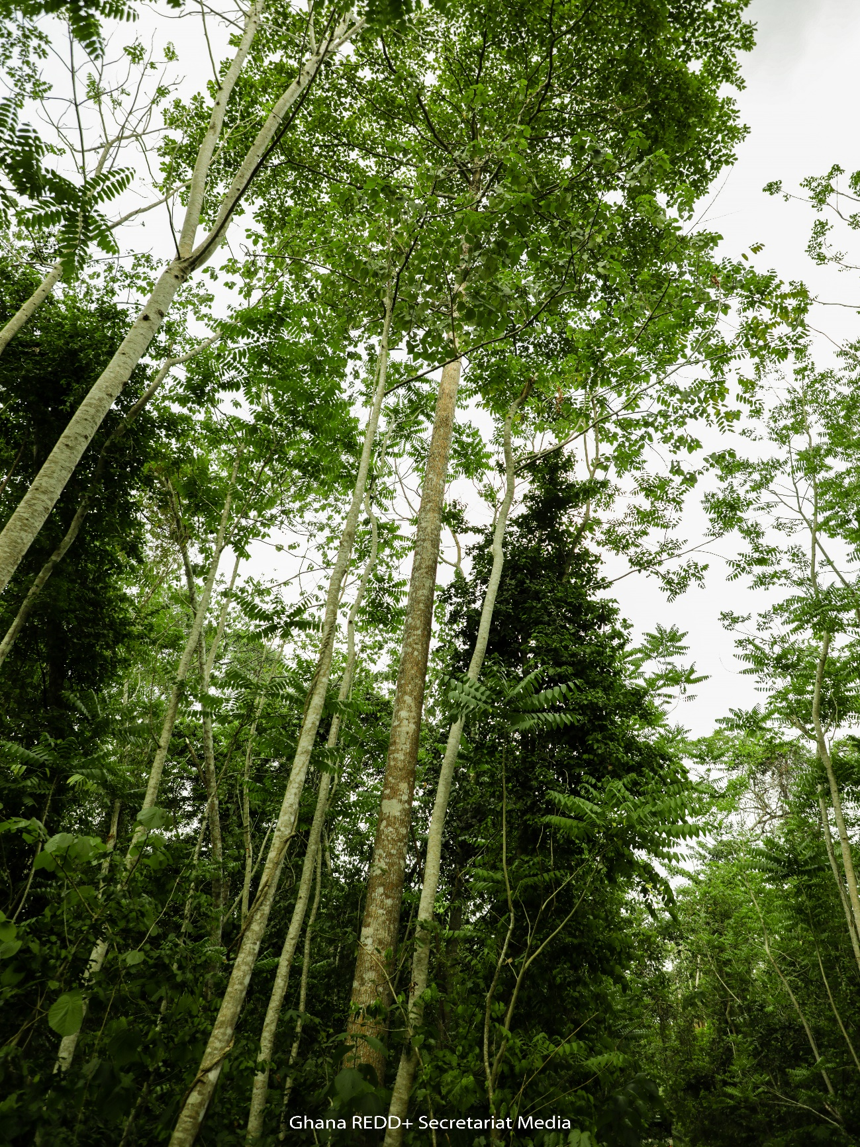

REPORT ON UPFRONT ADVANCE PAYMENT ACTIVITIES FOR 2020 AND 2021

Table of Contents
LIST OF PICTURES iii
LIST OF TABLES iii
LIST OF ACRONYMS iv
INTRODUCTION 1
PLANTING ACTIVITIES UNDER THE GCFRP (MTS, ENRICHMENT PLANTING & TREES-ON-FARM): 2
The GCFRP Implementation Committee Meetings 3
Description of stepwise process 3
Strategy for Planting Activities 4
Modified Taungya System (MTS) plantations 4
Enrichment Planting 5
Trees on farms (ToF) 6
OPERATIONALIZATION OF FEEDBACK AND GRIEVANCE REDRESS MECHANISM (FGRM) 8
PROVIDE VIABLE ECONOMIC LIVELIHOOD OPTIONS 9
SENSITIZATION OF FOREST FRINGE COMMUNITIES ON CLIMATE SMART COCOA PRACTICES 11
TRAINING SESSIONS 11
CLIMATE SMART COCOA PRODUCTION 11
FARMER BUSINESS SCHOOL (FBS) 11
DEVELOPMENT OF HIA GOVERNANCE STRUCTURE 13
JUABOSO-BIA HIA 13
KAKUM HIA 13
AHAFO-ANO SOUTH ATWIMA MPONUA, ATWIMA NWABIAGYA HIA 14
ASUNAFO- ASUTIFI HIA 14
SEFWI-WIAWSO BIABIANI HIA 14
PROGRAM MONITORING AND REPORTING 15
PROCUREMENT OF LOGISTICS: 18
SUMMARY OF PROCUREMENT PROCESS 18
MONITORING REPORTING AND VERIFICATION (MRV) 19

LIST OF PICTURES
Picture 1: GCFRP Implementation Committee Meeting at FC 6
Picture 2: GCFRP Implementation Committee Meeting at FCTC 6
Picture 3: Picture of Landscape Level Stakeholder Engagement on Safeguards and FGRM 12
Picture 4: Engagement of farmers on Livelihoods Options 14
Picture 5: Participants of Climate Smart Cocoa Training at Jukwa and Asempanaye respectively 16
Picture 6: Participants of Farmer Business School at Jukwa and Asempanaye respectively 16
Picture 7: Field Monitoring in three HIAs 19
Picture 8: Verification of seedlings distribution 20
Picture 9: Safeguards Monitoring and Landscape Engagement 20
Picture 10: Safeguards Monitoring 21

LIST OF TABLES
Table 1: Summary of activities undertaken to date as per workplan 4
Table 2: Details on the progress of MTS plantation establishment 7
Table 3: Details of Enrichment Planting Activities 8
Table 4: Details on the ToF activities by Cocoa Companies. 9
Table 5: Details on the ToF activities by COCOBOD 10
Table 6: Details of farmer participation at FBS 15
Table 7: List of logistics procured to support GCFRP implementation 22
Table 8: List of Covid19 items procured 22
Table 9:Stakeholder Engagement on Monitoring Report 22

LIST OF ACRONYMS
Acronym Meaning
AccelREDD Accelerating REDD+
BSP Benefit Sharing Plan
CCD Climate Change Directorate
FC Forestry Commission
FRL Forest Reference Level
GCFRP Ghana Cocoa Forest REDD+ Programme
M&E Monitoring & Evaluation
MLNR Ministry of Lands and Natural Resources
NRS National REDD+ Secretariat
NRWG National REDD+ Working Group
P4F Partnership for (4) Forests
REDD+ Reducing Emissions from Deforestation and forest Degradation plus conservation, sustainable management of forests and enhancement of forest carbon stocks
SIS Safeguards Information System
SOPs Standard Operating Procedure
TBG Tropenbos Ghana
UNFCCC United Nations Framework Convention on Climate Change
WB World Bank

INTRODUCTION
As part of negotiations during the Emission Reductions Payment Agreement (ERPA) for the Ghana Cocoa Forest REDD+ Program (GCFRP), the Forestry Commission (FC) made a request for an Upfront Advance Payment (UAP) of USD1,300,000.00 which was granted. This report provides information on the activities that the UAP is being used to undertake according to a detailed work plan that received NO OBJECTION from the Word Bank on September 03, 2020.
Table 1: Summary of activities undertaken to date as per workplan
Activity | Total  Budget  (USD) | Expenditure to Date  (USD) | Estimated % of Progress | Remarks
Distribute Seedlings to CS cocoa farmers (Agroforestry) in operational HIAs (16,000ha)
Procure & Supply tree seedlings to farmers ( $0.6/ seedling) | 192,000 | 46,845 | 24% | Seedlings Distributed to various beneficiaries (Cocobod, WCF). Payment yet to be made. Initial Expenditure mainly on monitoring of the distribution
Identify, verify and confirm selected sites for Trees on Farm | 24,000 | 24,000 | 100% | Activity Completed
MTS Plantations establishment, maintenance and monitoring (100ha in 2021) in operational HIAs
Procure and supply 133320 seedlings (including 20% beating up) ($0.6/seedling) to farmers | 79,992 | 23,617 | 30% | Seedlings for the 101ha plot procured but yet to be paid. Initial expenditure on monitoring of seedlings distribution
Identify and screen selected sites for MTS | 15,000 | 14,274 | 95% | Activity Completed
Survey, Demarcate and Prepare site | 10,000 | 7,369 | 45% | Activity Completed
Peg Cutting / Pegging | 6,500 | 7,369 | 45% | Activity Completed
Operationalize FGRM
Sensitization of Communities on FGRM Operational Modalities (workshops, radio jingles, community centre announcement etc) | 12,100 | 2,132 | 18% | English Radio Jingle developed. Local language development on going
Provide Viable Economic Livelihood options (Baking/ Vegetable farming/ Soap, Hand sanitizer making/Honey Production etc)
Support local livelihoods including capacity building through trainings, input support, and offtake agreements as relevant based on consultant report recommendations. The work will be supported through hiring of Technical Support Personnel or FC / COCOBOD, as relevant | 220,000 | 80,151 | 36% | Initial consultations by GCFRP Implementation committee in 5 HIAs to come up with the list of livelihood options undertaken. This would guide the consultancy
Sensitization of forest fringe communities on Climate Smart Cocoa Practices
Organize training for farmers on Climate Smart Cocoa Practices | 32,000 | 12,000 | 38% | 251 farmers benefitted in Jauboso and Kakum HIAs. CSC sensitization planned for October 2021 in the Ahafo Ano & Asunafo/Asutifi HIAs
Support the Organization of business school for farmers (book keeping/ savings etc) | 25,000 | 9,911 | 40% | 134 farmers benefitted in Juaboso and Kakum HIAs. FBS planned for Ahafo Ano and Asutifi/Asunafo for October 2021
Development of HIA governance Structure
Continuous engagement of HMBs/ Sub HIA/CREMA Executives on their roles and responsibilities regarding the Framework Agreements/ Benefit Sharing/ Fund Flow Mechanism | 10,000 | 0 | 0% | Mostly undertaken during the monitoring of activities. Also, for Asunafo & Ahafo Ano HIAs, the governance consultancy undertook these engagements.
Support meetings and development of HIA governance structures | 7,000 | 761 | 11% | Mainly for payment of transportation for HMB and community members
Enrichment Planting (5 compartments in 5 forest reserves)
Identify 'poorly stocked' Compartments for Enrichment Planting | 18,000 | 20,265 | 113% | Activity Completed
Engage Community workers to undertake Enrichment Planting | 39,999 | 31,664 | 79% | Activity completed. One round of tending would be undertaken before the year ends
Program Monitoring and Reporting
Monitor activities (MTS, distribution of seedlings to farmers, enrichment planting, livelihood options, cocoa trainings, governance structures, etc.) | 80,000 | 57,143 | 71% | A number of field visits already undertaken; more monitoring yet to be done
Procure Logistics (GPS, Cameras, GIS Software, Printers) | 50,000 | 32,139 | 64% | Amount Allocated for 2020 expended for the logistics, through FC internal procurement process
In-country stakeholder engagement of forest monitoring new methodology | 30,000 | 33,247 | 111% | Activity Completed
Test run in-country capacity on new forest monitoring methodology for reporting | 20,000 | 19,959 | 100% | Activity Completed
Purchase Sanitizers/Face masks/ Face Shield etc for field trips, monitoring /workshops etc | 90,216 | 25,165.79 | 28% | Covid19 items procured in 2020 through FC internal procurement process
Specialised Programme Support
PMU Coordinator | 25,215 | 16,133.30 | 64% | Coordinator undertaking activities
Contract Staff | 34,500 | 13,670.83 | 40% | Safeguards and Governance contract staff procured and supporting GCFRP activities

PLANTING ACTIVITIES UNDER THE GCFRP (MTS, ENRICHMENT PLANTING & TREES-ON-FARM):
This activity was aimed at carbon stock enhancement within the GCFRP area. Two key stakeholder engagements were undertaken as follows:

The GCFRP Implementation Committee Meetings
A GCFRP Implementation Committee meeting was organized on the 21st of January, 2021 to discuss 2021 UAP workplan for the outlined planting activities at the FC.
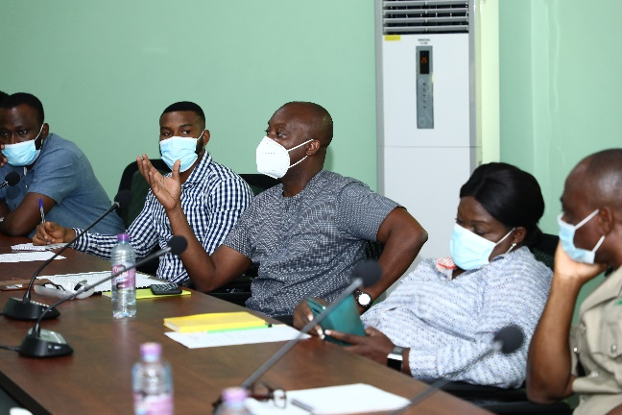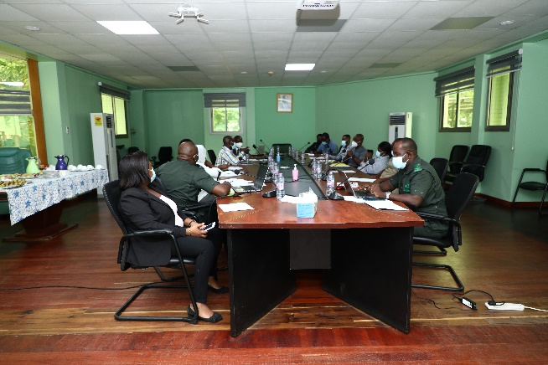
Picture 1: GCFRP Implementation Committee Meeting at FC
Another meeting was held with representatives from FC/COCOBOD Regional and District offices on 30th March, 2021 to identify, pre-screen and select potential sites for undertaking 2021 planting activities and plan for a field verification of the selected planting sites at the Forestry Commission Training Centre (FCTC).

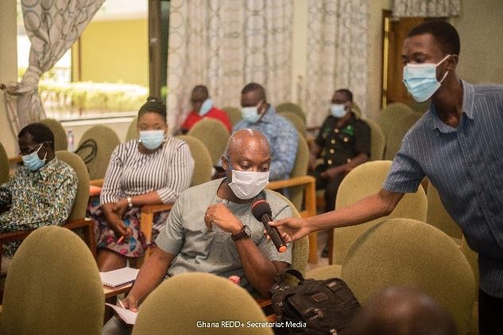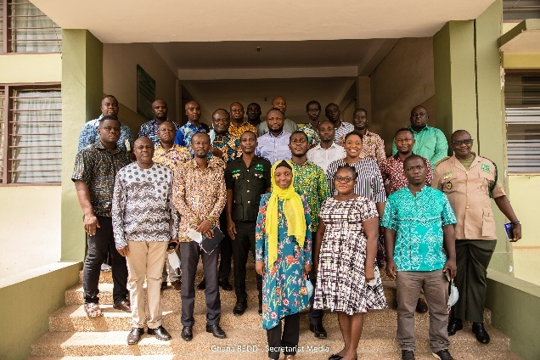
Picture 2: GCFRP Implementation Committee Meeting at FCTC

Description of stepwise process
Subsequent to the stakeholder engagements, confirmation of the identified planting sites was done by Regional and District offices of the Forestry Commission. A team from the GCFRP Implementation Committee undertook field visit to all the HIAs to confirm and validate selected planting sites from April 06 – 16, 2021 after which contracts for the supply of tree seedlings (including Mansonia spp, Pericopsis elata (Kokrodua), Khaya ivorensis (Mahogany), Terminalia superba (Ofram), Terminalia ivorensis (Emire), Triplochiton scleroxylon (Wawa), Cedrela odorata (Cedrella)) and temporary shade trees (plantain suckers) were awarded by Regional and District offices of FC and COCOBOD. Include the verification of nursery sites.
Site preparation was undertaken with supervision from Regional and District offices after confirmation and validation of these sites. On the onset of the rains, seedlings (Tree and shade) were distributed to farmers at the various planting sites. The GCFRP Implementation Team went on another field visit to monitor the seedlings distribution from June 28 – July 03, 2021.

Strategy for Planting Activities
The carbon stock enhancement was undertaken using three key strategies namely:
- Modified Taungya System (MTS) plantations
- Enrichment Planting
- Trees on farms

Modified Taungya System (MTS) plantations
This is a system of agroforestry practice where farmers from fringe communities of Degraded Forest Reserves are allocated degraded areas on reserve to undertake plantation development. In this system, farmers provide labour for the site preparation, pegging, planting and tending of the plantation. The Forestry Commission provides logistics (tree seedlings to plant and some other farming tools as well as protective clothing include pegs) and Technical support to the farmers. Farmers are allowed to grow food crops along with the tree seedlings and harvest the crops for themselves whiles tending the tree seedlings for three to four years when tree canopy closes and crop production becomes impossible under the shade. A Benefit Sharing Plan has been instituted for the MTS with a proportion of 40% : 40% : 15% : 5% to Farmers, Forestry Commission, Community and Traditional Authorities respectively.
After demarcation of selected sites for MTS, a total area of 101Ha was obtained within two (2) Forest Reserves (FR) namely Apimanim Forest Reserve in the Assin Fosu Forest District of the Kakum HIA and Krokosue Forest Reserve in the Juabeso Forest District of the Juabeso - Bia HIA. Planting target for Apimanim FR is 40Ha in compartment 8 whiles that for Krokosue FR is 61Ha in compartments 261/262, 143/144 and 40. Table 1 below provides details on the progress of MTS plantation establishment.
Indicate the overall selection criteria for the communities or farmers and also indicate if these farmers are in the governance structure.
Table 2: Details on the progress of MTS plantation establishment
Hotspot Intervention Area /Forest District | Report from field monitoring
Kakum HIA / Assin Fosu Forest District | Compartment 8 (40 Ha): Apimanin Forest Reserve  - A total of 51,000 tree seedlings have been supplied and planted  - Tree species supplied were Cedrela odorata. and Terminalia superba (Ofram).  - A total of 40Ha have been planted,Total number of farmers are 63 (53 males & 10 females)
Juaboso – Bia HIA / Juabeso Forest District | Compartment 261/262 (30 Ha): Krokosue Forest Reserve:  - A total of 33,330 tree seedlings supplied  - Area planted is 30Ha  - Tree species supplied were Cedrela odorata. and Terminalia superba (Ofram).  - 30 Ha of the site was pegged  - Total number of farmers are 63 (43 males & 20 females)  Compartment 143/144 (22 Ha) & 40 (9 Ha):  - A total of 34,441 tree seedlings supplied  - Area planted is 31Ha.  - A total of 31Ha pegged.  - Total number of farmers are 63 (38 males & 25 females)

Enrichment Planting
Enrichment planting describes a process of human intervention in supporting a fairly degraded forest to increase tree cover by practically planting tree seedlings within the forest. Two Forest Districts were selected for this activity, namely; Mankraso Forest District in the Ahafo Ano South HIA and Goaso Forest Districts in Asunafo-Asutifi HIA. At Mankraso Forest District, compartments 3 & 4 of the Tinte Bepo Forest Reserve were selected whereas at Goaso Forest District, compartment 7 & 9 of the Goa Shelterbelt Forest Reserve were selected. The table below provides details of activities undertaken so far:
Table 3: Details of Enrichment Planting Activities
Hotspot Intervention Area /Forest District | Report from field monitoring
Ahafo Ano South HIA/Mankraso Forest District | Compartment 3 & 4 (286.52Ha): Tinte Bepo Forest Reserve  - Completed demarcations for compartments 3 & 4.  - Strip cutting completed  - Planting completed.  - 20,000 tree seedlings supplied.  - Tree species supplied were Khaya ivorensis (Mahogany), Terminalia ivorensis (Emire) and Terminalia superba (Ofram).
Asunafo Asutifi HIA/Goaso Forest District | Compartment 7 & 9 (280.72Ha): Goa-Shelterbelt Forest Reserve  - Completed demarcations for compartments 7 & 9.  - Strip cutting completed  - Completed pegging and planting  - 30,000 tree seedlings supplied.  - Tree species supplied were Khaya ivorensis (Mahogany), Terminalia ivorensis (Emire) and Terminalia superba (Ofram).
Sefwi Wiawso – Bibiani HIA / Sefwi Wiawso Forest DIstrict | Compartment 105 & 106 (265.38Ha): Sui River Forest Reserve  - Completed demarcations for compartments 105 & 106.  - Strip cutting completed  - Completed pegging and planting  - 23,000 tree seedlings supplied.  - Tree species supplied were Khaya ivorensis (Mahogany), Terminalia ivorensis (Emire) and Terminalia superba (Ofram).

Trees on farms (ToF)
This system of carbon stock enhancement focuses mainly on cocoa farms that are unshaded or not fully shaded according to the right regime. Farmers are encouraged to incorporate trees in their farms to ensure sustainable yield whilst at the same time contributing to Climate Change Mitigation. By incorporating trees on their farms, they contribute to carbon stock enhancement which serves as a carbon sink.
In executing this model, COCOBOD and some cocoa companies were made to lead implementation since they have already existing engagement arrangements with farmers in which farmers benefit from technical support in terms of agricultural extension services as well as supervision and logistical support.
Eight COCOBOD Districts were chosen out of the consultative processes for ToF implementation namely: Assin Fosu, Jukwa, Twifo Praso, Goaso, Ajoafua, Mankraso, Dadiesoaba and Sankore. They cover four (4) Hotspot Intervention Areas (HIAs), namely: Kakum, Juaboso-Bia, Ahafo Ano South and Asunafo-Asutifi.
Additionally, the ToF implementation involved five (5) cocoa companies namely: Kuapa Kokoo, Touton, Cargill, Mondelez and Kokoo Pa). Table 3 and 4 below provide details on the ToF activities.

Table 4: Details on the ToF activities by Cocoa Companies.
HIA/ FOREST DISTRICT | PRIVATE SECTOR COMPANY | COMMUNITY | TARGET (Ha) | STATUS
Juaboso-Bia/ Juaboso | Touton | Juaboso | 2000 | 40,000 seedlings supplied.  PMU provided financial support towards community-level lifting of seedlings to farmer beneficiaries in the following communities: Donkokrom, Abuoso, Dangermu, Yawmetwa,Nsowaakrom.
Kakum/ Assin Fosu | Kuapa Kokoo | Assin Breku | 500 | 10,000 seedlings supplied.  PMU provided financial support towards community-level lifting of seedlings to farmer beneficiaries
Asunafu-Asutifi/ Goaso | Mondelez | Goaso | 2,000 | 40,000 seedlings supplied.  PMU provided financial support towards community-level lifting of seedlings to farmer beneficiaries in the following communities; Akrodie, Ahenkro, Awehonmanhyia, Tipokrom, Manukrom, Kwartengkrom, Antwi-Agyeikrom, Mmawoninha, Asumura, Pomaakrom, Mfante, Ampenkrom, Abidjan, Nyamebekyere, Bediako, Fawohoyeden
Wiawso-Biniani/ Sefwi Wiawso | Cargill | Sefwi Wiawso | 1000 | 20,000 seedlings supplied.  PMU provided financial support towards community-level lifting of seedlings to farmer beneficiaries in the following communities; Boako, Anyinabrem, Kojo-hunu, Kwamokrom, Mile 3, Akofu
Ahafo-Ano South/ Nkawie | Kokoo Pa | Atwima Nwabiagya | 500 | 10,000 seedlings supplied.  PMU provided financial support towards community-level lifting of seedlings to farmer beneficiaries in the following communities: Amoakokrom, Pokuase, Sabronum Camp, Gyawukrom, Aponaponosu, Sabronum Nyamebekyere, Ahwerwam, Nsuta Nyamebekyere, Mmrobem
Total | 6,000

Table 5: Details on the ToF activities by COCOBOD
HIA | DISTRICT | CHED DISTRICTS | Beneficiary Communities | TARGET (Ha) | STATUS  (PMU provided financial support towards community-level lifting of seedlings to farmer beneficiaries.
Kakum | Assin Fosu | Twifo Praso | Akrofuom, Dominase,Akropong  Adukrom, Adadientem, Betinsinso, Dompim  Abodweseso, Homaho, Edubias  Kwafokrom, Akoyem  Adadientem,Andoe  Adiembra, Nsabaah  Amponsahkrom,Mpentemmua  Gyhadzi, Broniayebi, Ababuom  Obranewoarabo,Nyankomasu  Adiembra Krawura, | 1000 | 20,000 seedlings supplied
Kakum | Assin Fosu | Jukwa |  | 1000 | 20,000 seedlings supplied
Kakum | Assin Fosu | Fosu |  | 1000 | 20,000 seedlings supplied
Juaboso-Bia | Juaboso | Adjofua | Adjofua, Osonokrom, Bonoie, Mesrenyame, Osumanikrom, Obeykrom, K. T. K, Mempeasem, Asanteman, Atemuda, Elluokrom, Mfanteman, Acheakwaw, Tigare, Biano, Sakyikrom, Yesukrom, Akweikrom, Kumikrom, SIKANEASEM, Assemnyinaakrom, Nyame Nti, Secretarykrom, Paddykrom, Kramokrom | 2000 | 40,000 seedlings supplied
Ahafo Ano South | Mankranso | Mankranso |  | 1500 | 15,000 seedlings supplied
Asunafo Asutifi | Goaso | Sankore | Tenso, Nsunamah, mankesim, Subrisu, Oseikrom | 1000 | 20,000 seedlings supplied
 |  | Goaso | Tenso, Nsunamah, mankesim, Subrisu, Oseikrom | 2000 | 40,000 seedlings supplied
 |  | Dadiesoaba | Tenso, Nsunamah, mankesim, Subrisu, Oseikrom | 1000 | 20,000 seedlings supplied
Total |  |  |  | 10, 500

OPERATIONALIZATION OF FEEDBACK AND GRIEVANCE REDRESS MECHANISM (FGRM)
A key activity in operationalizing FGRM is undertaking extensive and continuous public sensitization and awareness creation as well as education on the need to provide feedback on REDD+ implementation outcomes and impacts, whiles also providing avenues for reporting grievances that may result. The NRS through various trainings and workshops as well as field visits at mainly the landscape level have enhanced continuous awareness creation, capacity building and sensitization amongst key stakeholders on the FGRM and its modalities at Kakum, Juaboso-Bia, Asunafo-Asutifi, Ahafo Ano South, and Sefwi Wiawso-Bibiani HIAs (including Safeguards Field Monitoring and Engagement from May 11 – 21, 2021 and Sub-National Stakeholder Engagement Meetings from November 19 - 27, 2020). The stakeholders include Safeguards Focal Persons, Safeguards Teams, HMB/CREMA Executives, Forestry Commission District Managers, District Assembly, Agric Department, Environmental Protection Agency, NGOs/CSOs, and Private Sector partners.
Radio jingle on FGRM has also been developed to sensitize communities and farm settlements through Radio, information centers and Community Centers broadcasts.
FGRM complaint/ grievance forms have been printed out and distributed to FC District Offices. Most of the feedback and grievances received by the forest district offices were on:
- Grievance or complaintsInadequate logistics supply to farmers such as wellington boots, cutlasses among others.
- Other complaints received are on illegal logging and illegal farming, which are addressed by FC's laid down rules and regulations. These grievances have been reported by the FC in 5 HIAs (Juaboso, Kakum, Ahafo Ahafo South, Asunafo-Asutifi and Sefwi Wiawso-Bibiani).
- The grievances received by the FC Park Mangers are mainly on elephant crop raiding where elephants move out of the parks to destroy cocoa farms and other food crops.
Feedback
- Farmers and community members have suggested an indigenous and innovative way of repelling elephants and thus preventing farm destruction through alligator pepper fencing around farms.
- More farmers and community members have become interested in the MTS plantations upon witnessing payments of cash benefits to various taungya groups who engaged in MTS in the past.
Some farmers are reluctant to allow rehabilitation on their cocoa farms because of the fear of losing the farm land to the land owners once the cocoa trees have been cleared. The FC (WD), as a way of addressing the issue of elephant crop raiding, educate farmers on elephant behavior and train them on how to undertake some measures in repelling or scaring the elephants away.
Also, COCOBOD have developed an FGRM register to receive and address complaints or grievances of the stakeholders especially farmers. Some of the grievances reported include:
- Delay in supply of farm inputs (such as fertilizers, cocoa seedlings, chemicals among others).
- Delay in cutting down diseased cocoa trees when reported as part of COCOBOD Cocoa Rehabilitation Program. Most of these grievances are resolved through negotiation and the provision of the required farm inputs to farmers.
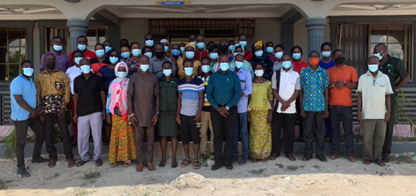
Picture 3: Picture of Landscape Level Stakeholder Engagement on Safeguards and FGRM

PROVIDE VIABLE ECONOMIC LIVELIHOOD OPTIONS
The activity undertaken is to support local farmers’livelihoods through capacity building and training workshops. This was undertaken by two teams in all the five (5) HIAs (Juaboso, Kakum, Ahafo Ahafo South, Asunafo-Asutifi and Sefwi Wiawso-Bibiani) from December 14 – 24, 2021 with the following objectives:
- To consult key stakeholders on alternative/additional livelihood to be provided under the GCFRP to farmers.
- To engage and solicit stakeholder’s impressions, perspectives, lessons and experiences regarding the said initiatives
- To validate criteria for selecting beneficiaries (individuals/groups) in undertaking the livelihood options.
Two levels of engagements process were employed:
- Engagement with Regional, District and Park Forestry Commission Offices, COCOBOD, private sector and other key stakeholders within the GCFRP area.
- Engagement with selected communities through the HIA governance structure.
In all, One Hundred and Forthy (140) stakeholders were consulted at the four HIAs as follows: Asunafo Asutifi (22), Sefwi Wiawso (43), Juabeso-Bia (16) and Kakum (59). Stakeholders were sought from various groupings including; FC District and Regional offices, Community members, HMB representatives, NGOs, other government institutions (ie MoFA, MMDAs, Ghana Fire Service, Police Service)cocoa private sector.
Stakeholders were made to suggest preferred livelihoods options based on a number of conditions as follow; Reliable market, Previous experience and skills, Access to resources, Willingness and commitment to engage in it, Inherent local expertise, after which they were prioritized per consensus.
Generally, HIA local actors settled the following preferred livelihood options:
a) Vegetable farming b) Soap making
c) Bee-Keeping
d) Gari processing e) Oil palm processing f) Piggery

Per trend analysis done from the four HIAs with respect to prioritized livelihoods options by stakeholders, the following options stood out among the first three options:
- Vegetable farming
- Soap making
- Piggery
- Bee keeping

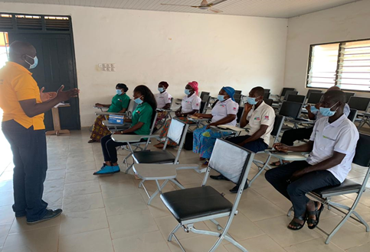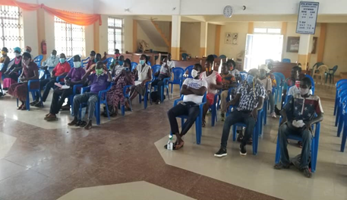
Picture 4: Engagement of farmers on Livelihoods Options

SENSITIZATION OF FOREST FRINGE COMMUNITIES ON CLIMATE SMART COCOA PRACTICES

NRS in collaboration with COCOBOD have organized training program on Climate Smart COCOA (CSC) and Farmer business school (FBS) for COCOBOD farmers and forest fringe communities within selected HIAs. Climate-Smart Cocoa or Agriculture is a pathway towards development and food security built on three (3) pillars:
- Increasing productivity and incomes
- Enhancing resilience of livelihoods and ecosystems
- Reducing and removal of greenhouse gas emission from the atmosphere
Also, registered cocoa farmers within each HIA require capacity to access financial services to enable them invest adequately in recommended CSC practices. In addition, most farmers have generally not treated cocoa farming as a business, thus, the need to organize business schools for cocoa farmers to build their capacities on basic bookkeeping, financial literacy skills and related farming business models.
The trainings were organized during the month of October 2020 with COCOBOD leading the implementation. Beneficiaries were selected from the two HIAs (Kakum and Juaboso-Bia) with 385 COCOBOD farmers drawn from selected communities.

TRAINING SESSIONS

CLIMATE SMART COCOA PRODUCTION
Two sessions were organised at Asempaneye community in the Juaboso-Bia HIA and Sesekor community close to Jukwa in the Kakum HIA. A total of 251 cocoa farmers comprising 162 males and 89 females selected from various communities benefited from the training sessions. In the Kakum HIA, 127 farmers attended the training whiles 124 participated in the Juabeso-Bia HIA.
Participants were taken through eight (8) well-structured thematic areas with each having its specific objective(s). Areas covered are as follows;
- Mechanism of climate change
- How trees clean the air
- Deforestation and cocoa farming
- Tree integration in cocoa farming
- Wildlife protection
- Ecosystem conservation
- Soil and water conservation
- Safe use and storage of agro-chemical

FARMER BUSINESS SCHOOL (FBS)
The main objective of FBS is to build farmers’ capacity in entrepreneurial and managerial skills. In order for smallholder farmers to adopt improved technique and invest in good agricultural practices, they must perceive the production as a business entity. The FBS models were taught for 5 continuous days with a total of 30 farmers in each class. There were four (4) separate trainings for four different groups each day. In all, the program recorded a total of 134 participants comprising 84 males and 50 females. Details are as follows:
Table 6: Details of farmer participation at FBS
NO. | REGION | DISTRICT | COMMUNITY | PARTICIPANTS
 |  |  |  | MALES | FEMALES | TOTAL
1 | WESTERN NORTH | JUABOSO | Anhweafutu | 28 | 10 | 38
2 | WESTERN NORTH | JUABOSO | Asempaneye | 30 | 5 | 35
3 | CENTRAL | JUAKWA | Damintikro | 19 | 11 | 30
4 | CENTRAL | JUAKWA | Nyamebebu | 7 | 24 | 31
TOTAL |  |  |  | 84 | 50 | 134

Participants were taken through twelve (12) well-structured modules with each having its specific objective. The figure below gives an overview of the twelve (12) modules.
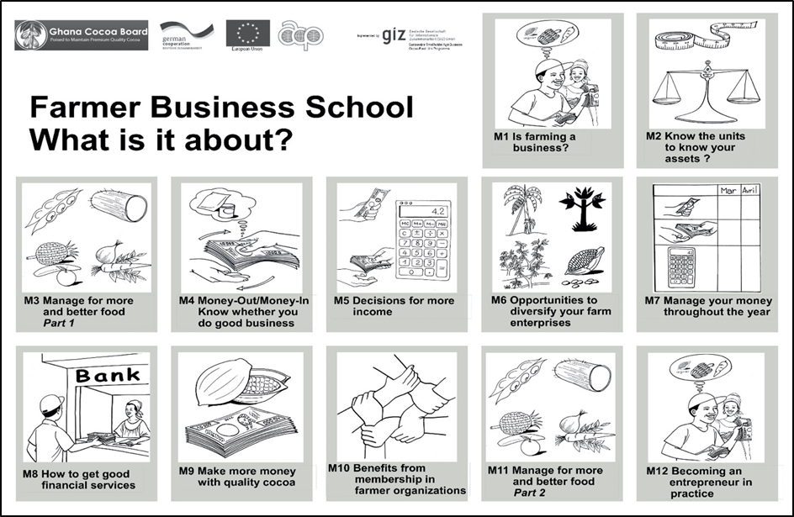
Figure 1:Overview of 12 models for Farmer Business School

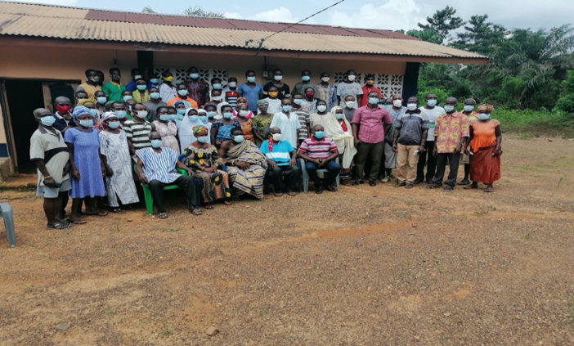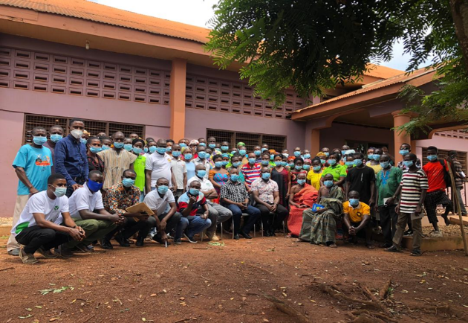
Picture 5: Participants of Climate Smart Cocoa Training at Jukwa and Asempanaye respectively
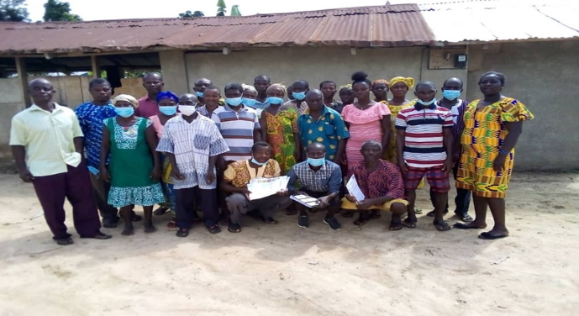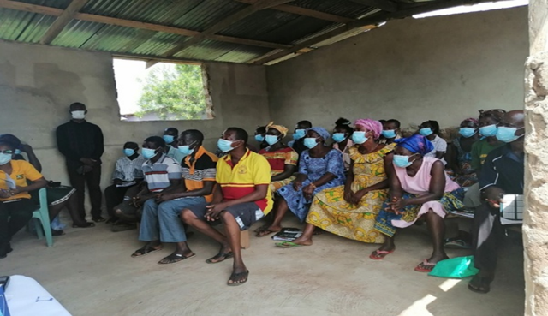
Picture 6: Participants of Farmer Business School at Jukwa and Asempanaye respectively

DEVELOPMENT OF HIA GOVERNANCE STRUCTURE

JUABOSO-BIA HIA
Juaboso-Bia HIA is set up in the Bia West and Juaboso administrative Districts in the Western North Region of Ghana. Governance structures namely; HIA Management Board (HMB), Sub-HIA Executive Committees (SHEC), CREMA Executive Committees (CEC) & Community Resource Management Committees (CRMCs) are fully developed and a framework Agreement has been signed amongst Forestry Commission, Ghana COCOBOD and the Hotspot Management Board. Before the introduction of the HIA structures there were several CRMCs and about ten CREMAs already existing. As there was no need to reinvent the wheel, the existing structures were adapted forming the basis to enable proponents to have proceeded to forming the upper tiers of the governance structures (Sub-HIAs and HMB) in a landscape-wide fashion. In all, there are six Sub-HIAs (Juaboso, Sukusuku-Debe, Krosue Hills, Yawmetwa, Asuo-Bia and Asuo Pri) being headed by a seven member SHEC for Sub-HIA. Moreover, there is a 13 member HMB in place that form the apex decision making body of the entire governance structure. To ensure inclusion and participation, communities without CRMCs and CREMA have also been included in the process and are designated as non-CREMA areas.
Some of the key interventions carried out by partners include the following: Touton Climate Smart Agriculture; Modified Taungya System, Enrichment Planting, Trees-On-Farm by Forestry Commission, and COCOBOD Cocoa Rehabilitation Programme. Strategic Partners include: Forestry Commission, Cocoa Board, Touton, WCF, SNV, Tropenbos Ghana and Agro-Eco.

KAKUM HIA
The Kakum HIA is being set up in the Central Region of Ghana. Governance structures development in the Kakum HIA is currently ongoing. Four Community Resource Management Areas (CREMAs) have been developed into one Sub-HIA. Additionally, three CREMAs have been developed with CREMA executives selected for subsequent formation of a second Sub-HIA. Again, community entries have begun for the formation of Community Resources Management Committees for the 3rd Sub-HIA development. After the third HIA, the next step will be to develop Hotspot Management Board (HMB) in this HIA. The Governance structures are expected to be fully developed by end of December, 2021 with signing of Framework Agreement. Some of the key interventions carried out by partners include the following: Kakum Cocoa Agroforestry Project; Modified Taungya System, Enrichment Planting, Trees-On-Farm by Forestry Commission, and COCOBOD Cocoa Rehabilitation Programme. Strategic Partners include: Cocoa Board, Forestry Commission, WCF, Hershey, Ecom, Lindt Cocoa Foundation, Olam, Nyonkopa.

AHAFO-ANO SOUTH ATWIMA MPONUA, ATWIMA NWABIAGYA HIA
This HIA is set up in the Ahafo-Ano South, Atwima Mponua & Atwima Nwabiagya administrative districts in the Ashanti and Ahafo regions of Ghana. The Ahafo Ano South-Atwima Nwabiagya-Atwima Mponua HIA has been formed as an aggregation of five political districts which include two forest district and seven Cocoa districts. As the process began without any existing government recognized local decision making structures, rapid assessment was carried out to determine the suitability of the area is suitable-i.e. whether or not the prospective constituent communities have collective action and unity and also ascertain the land ownership and decision making structures, state of the resource base and land uses among other social-ecological considerations. Presently, landscape governance structures have been fully developed with the formation of CRMCs, CECs, SHECs and HMB. The GCFRP Framework Agreement for the HIA has signed amongst Forestry Commission, Ghana COCOBOD and the Hotspot Management Board. In all, there are 4 Sub-HIAs (Ahafo Ano North, Ahafo Ano South, Atwima Mponua and Atwima Nwabiagya) being headed by elected SHEC for Sub-HIA. A nine member HMB has been established.
Some of the key interventions carried out by partners include the following: Modified Taungya System, Enrichment Planting, Trees-On-Farm by Forestry Commission, and COCOBOD Cocoa Rehabilitation Programme. Strategic Partners include: Forestry Commission, COCOBOD, Tropenbos Ghana and WCF.

ASUNAFO- ASUTIFI HIA
It is set up in the Ahafo Region of Ghana. The Asunafo-Asutifi HIA encompasses four administrative districts namely: Asunafo North, Asunafo South, and Asutifi North and Asutifi South. The Asunafo-Asutifi HIA has been formed as an aggregation of one Forest District and four Cocoa Districts. Governance structures for the Asutifi-Asunafo HIA have formed with the formation of CRMC, CEC, SHEC and HMB. GCFRP Framework Agreement has been signed amongst Forestry Commission, Ghana COCOBOD and the Hotspot Management Board.There are 11 member HMB, 5 Sub-HIAs, 30 Zones and 365 CRMCs that characterize its built-up governance structures.
Some of the key interventions carried out by partners include the following: the Mondelez-UNDP International Cocoa Life Programme, Cocoa Rehabilitation and Improvement Project (CORIP), and the COCOBOD Cocoa Artificial Hand Pollination. Strategic Partners: Forestry Commission, Cocoa Board, WCF, Mondelez, UNDP, Proforest, Tropenbos Ghana

SEFWI-WIAWSO BIABIANI HIA
The HIA is located in the Western North Region of Ghana. Governance structure formation has been completed in the Sefwi-Wiawso portion that of Bibiani is on-going. In the Sefwi Wiawso portion, over 100 communities across the landscape with 76 community management committees, 16 clutter management committees and 2 separate Landscape Management Boards have been established.
Some of the key interventions carried out by partners include the following: Modified Taungya System, Enrichment Planting, Trees-On-Farm by Forestry Commission, and COCOBOD Cocoa Rehabilitation Programme and Partnership for Livelihoods and Landscape Management Project Strategic Partners: Cocoa Board, Forestry Commission, WCF, Olam & Rainforest Alliance

PROGRAM MONITORING AND REPORTING
Monitoring of GCFRP activities are being undertaken in close collaboration with FC District and Regional Offices with the recent inclusion of some data indicators to be collected and reported via FC’s monthly reporting system as part of processes to mainstream REDD+ into FC’s activities.
The PMU also undertake routine and frequent field visits to monitor the implementation of activities at the landscape level. The following are a few of monitoring activities undertaken by the PMU in collaboration with the GCFRP Implementation Committee.
- 1. Field monitoring visit to 3 HIAs (Juaboso-Bia, Kakum and Sefwi Wiawso Bibiani) within the GCFRP area scheduled from 17th-20th June, 2020.

Objectives
- Visit degraded landscape restoration sites and observe progress of work and the effects on the GCFRP
- Observe progress of work by private sector partners
- Engage with communities and HMB to discuss areas of continued support and engagements on implementation of planned activities.
- Meet with respective regional and district managers to discuss the expected responsibilities of Forestry Commission.

Outputs/Findings
- MTS and Enrichment planting sites within the Tano Sushien Forest Reserve in Sefwi Wiawso forest district were visited. Seedlings planted included Cedrella odorata (Cedrella), Khaya ivorensis (Mahogany), Terminalia superba (Ofram), Terminalia ivorensis (Emire), Triplochiton scleroxylon (Wawa).
- Farmers engaged conformed that their livelihoods have been improved by the food production from MTS.
- Some FC District and Regional staff were further engaged to explain the CCD sections in the monthly report template and other responsibilities to ensure success of GCFRP implementation
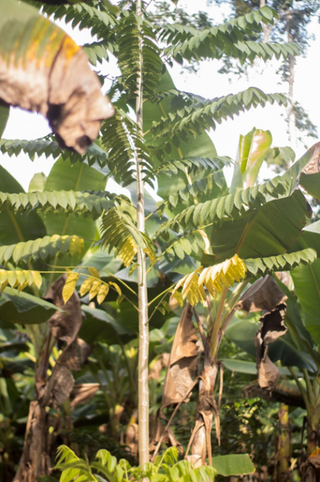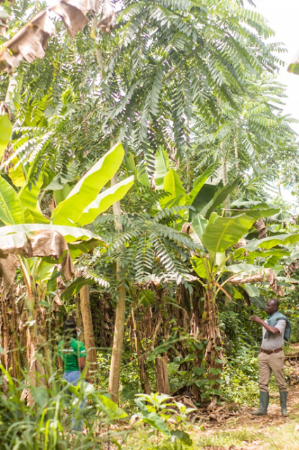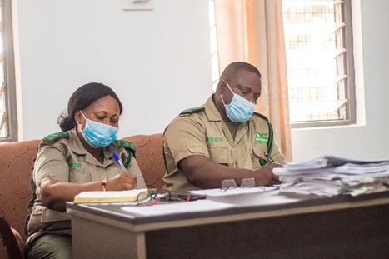
Picture 7: Field Monitoring in three HIAs
- 2. Monitoring of 2021 tree seedlings distribution: GCFRP scheduled from June 21st-July 3rd, 2021

Objectives
To monitor effectiveness of seedlings, supply and distribution for the Trees-On-Farm model, MTS and Enrichment planting in 4 HIAs (Juaboso-Bia, Kakum, Ahafo Ano South and Asunafo-Asutifi)

Outputs/Findings
- Monitoring of tree seedlings supply, distribution and implementation of MTS, enrichment planting and trees on farm undertaken.
- The HMB executives and farmers engaged offered to support the monitoring of activities and recommended continuous supervision and regular monitoring across project areas to ensure success.
- Districts where planting activities were made to document GPS coordinates of selected compartments boundaries.
- Community members and farmers requested that more MTS sites be allocated to vulnerable groups especially women to.
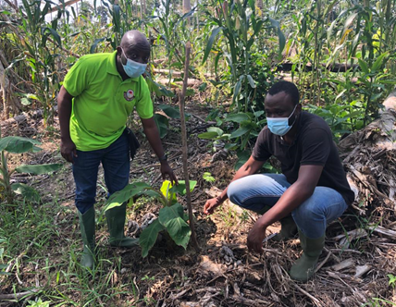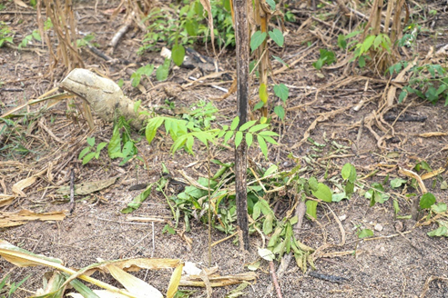
Picture 8: Verification of seedlings distribution

- 3. Safeguards Field Monitoring and Landscape Engagement scheduled from 11th -21st May, 2021
Objectives
a) To monitor how project proponents respect and address REDD+ safeguards
b) Initiate discussions towards the formation of Safeguards teams
c) Discuss the development of Safeguards Action Plans with stakeholders
d) To identify ongoing projects and develop Safeguards Action Plans subsequently
- To monitor the operationalization of the GCFRP Feedback Grievance Redress
Mechanism (FGRM) at the landscape level
Outputs/Findings
- The stakeholders engaged expressed interest towards the formation of the Safeguards team and the development of the SAP for each HIA.
- The stakeholders indicated their willingness to be part of the safeguards team in due cause and promised to nominate reps for the team formation
- Screening of MTS project undertaken in compartment 23 of the Ayum Forest Reserve under UNDP-Mondelez-Cocobod:- Environmentally Sustainable Practices in cocoa (ESP).
- Screening of Enrichment Planting project activity undertaken in compartment 7 and 9 in Goa Shelterbelt FR under the UAP.
- Sensitization ongoing by the Forestry Commission FSD office to create awareness on the FGRM.
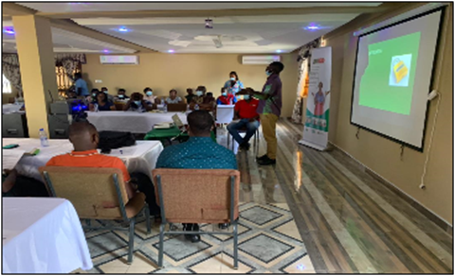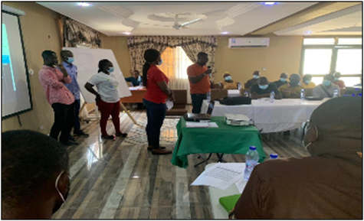
Picture 9: Safeguards Monitoring and Landscape Engagement

- 4. Safeguards Field Monitoring and Landscape Engagement scheduled from 11th August - 4th September, 2021
Objectives
- To guide project implementers in undertaking screening and gather data for the development of Safeguards Action Plans (SAPs)
- To monitor activities of stakeholders on Safeguards compliance
- To monitor the operationalization of the Feedback Grievance Redress Mechanism (FGRM)
- Enhance capacity of stakeholders on safeguards
Outputs/Findings
- All safeguards screening checklist within the 5 HIAs populated and submitted
- Primary information on activities towards the development of Safeguards Action plans were gathered.
- Capacities of stakeholders enhanced on the country approach to safeguards and compliance
- Safeguards institutional structures within HIAs were strengthened
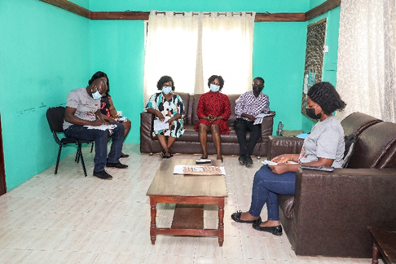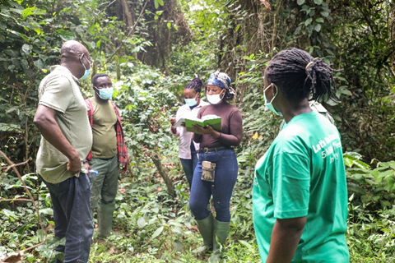
Picture 10: Safeguards Monitoring

PROCUREMENT OF LOGISTICS:
Through competitive process, the following items have been procured to support the operations of the PMU:
The Forestry Commission’s internal procurement processes were used to procure some logistics and Covid19 protective items to support implementation activities.

SUMMARY OF PROCUREMENT PROCESS
The procurement process commenced with the Director CCD submitting two separate memoranda to the Chief Executive requesting for the procurement of two sets of items (Covid19 items and other logistics). Upon approval of the request, an FC internal procurement meeting was organized to agree on specifications of the various items.
Subsequently a public call for Expression of Interest (EoI) to supply the items was made in the print media for a minimum of three (3) weeks which specified a date for bid openings. Upon receipt of submissions of EoI, the bids were opened on the specified date in the presence of representatives of the individual bidders. An evaluation meeting was held afterwards and a report was submitted to the Public Procurement Authority for approval before successful bidders are informed formally to supply items. Table 6 and 7 provides details of Covid19 items and other logistics procured to support GCFRP implementation.
Table 7: List of logistics procured to support GCFRP implementation
No. | Item | Quantity
1 | GPS | 20
2 | Printers | 3
3 | Camera | 1
4 | Projector | 1
5 | External Hard Drive | 10
6 | Network Scanner | 1
7 | Phones for Focal Person | 4

Table 8: List of Covid19 items procured
No. | Item | Quantity
1 | Hand Sanitizer | 150 gallons
2 | Nose Mask | 250 boxes
3 | Face Shield | 5000 pieces
4 | Rubbing Alcohol | 50 gallons
5 | Liquid Soap | 50 gallons
6 | Sanitizing Station | 2 pieces
7 | Humidifier/ Accessories | 4 pieces
8 | Kitchen Towels | 300 packs

MONITORING REPORTING AND VERIFICATION (MRV)
The first GCFRP Monitoring Report (MR) has been submitted to the FMT. A number of engagements have been undertaken subsequently to ensure completeness of the MR. A formal kick-off meeting for the commencement of Verification and Validation of the MR has been done on September 13,2021.
There has been a number of capacity building for in-country experts on new FRL methodology.
Table 9:Stakeholder Engagement on Monitoring Report
Stakeholder Group | Date | Key Issues discusses | Way Forward | Actions Taken
The GCFRP Implementation Committee | 22/09/ 2020 | * Challenges with the Stratified area estimation using change map as stratification and the current methodology; Systematic Sampling based approach | * To ensure minimum error in FRL estimation using New methodology | * New methodology used to estimate FRL with FAO Technical support
The Forestry Commission Executive Management Team | 22/10/ 2020 | * Possibility of a future conflict with the two different methodologies within same institution and landscape | * Systematic Sampling approach to be used until maps with higher accuracy are produced | * New methodology used to estimate FRL
The National REDD Working Group | 23/11/2020 | * Need for a third party to review new methodology | * Technical back stopping from FAO through World Bank support | * Work closely with FAO technical experts to develop new FRL
The Private Sector/ NGOs/ CSOs | 5/02/ 2021 | * Inconsistency in number of sample points data collection between Sub-National and National FRL | * Need to collect data on more sample points for National FRL | * 8,000 more sample data points have been collected for the National FRL
MRV Sub-Working GROUP | 23/04/ 2021 | * Justification of using the new methodology for degradation and enhancement estimation | * Need to provide a guide on the justification for use of new methodology | * NRS has collaborating with FAO to update SoP and explain the need for the new methodology

